- Purpose

The purpose of this procedure is to establish that the bagger is very clean and will function flawlessly for each shift.

- Scope

This procedure applies to all manufacturing workers.

- Responsibility

Lead Operator and / or Salt Operator

- Safety Considerations

All safety glasses and appropriate safety apparel is to be worn at all times.

Safety is a condition of employment. Employees are not authorized to work in an unsafe manner and are prohibited from harming the environment of the facility or community.

- Materials/Equipment

N/A

- Procedure

Daily Checks
- Clean gripper head and heater bars with wet rag.  - Clean area around machine.  - Check conveyors for wear, alignment, etc.  - Clean formatting head with ink conditioner.  - Clean pinch rollers with ink conditioner  (see Weekly Cleaning instructions for more detail)  - Clean eye mark sensor  (see weekly cleaning for detailed instructions)  - Zero scales  (see Shift Checklist for detailed instructions) | 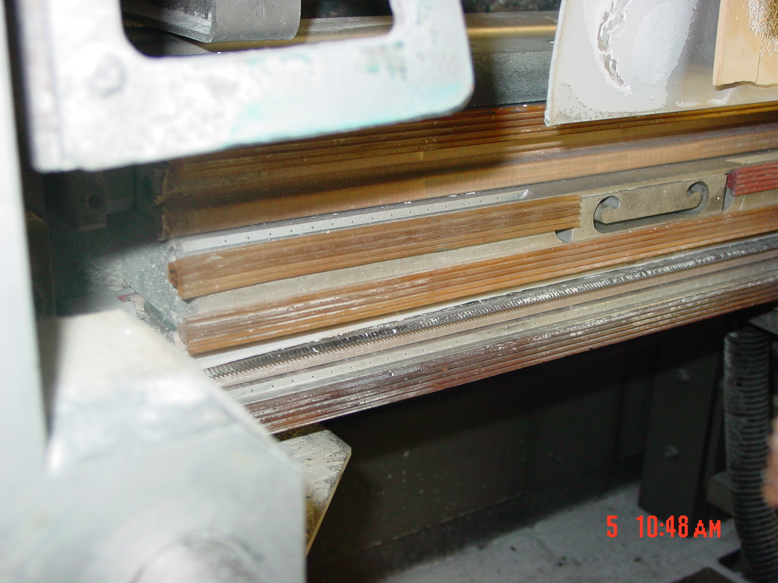  Thoroughly clean gripper strips and knife
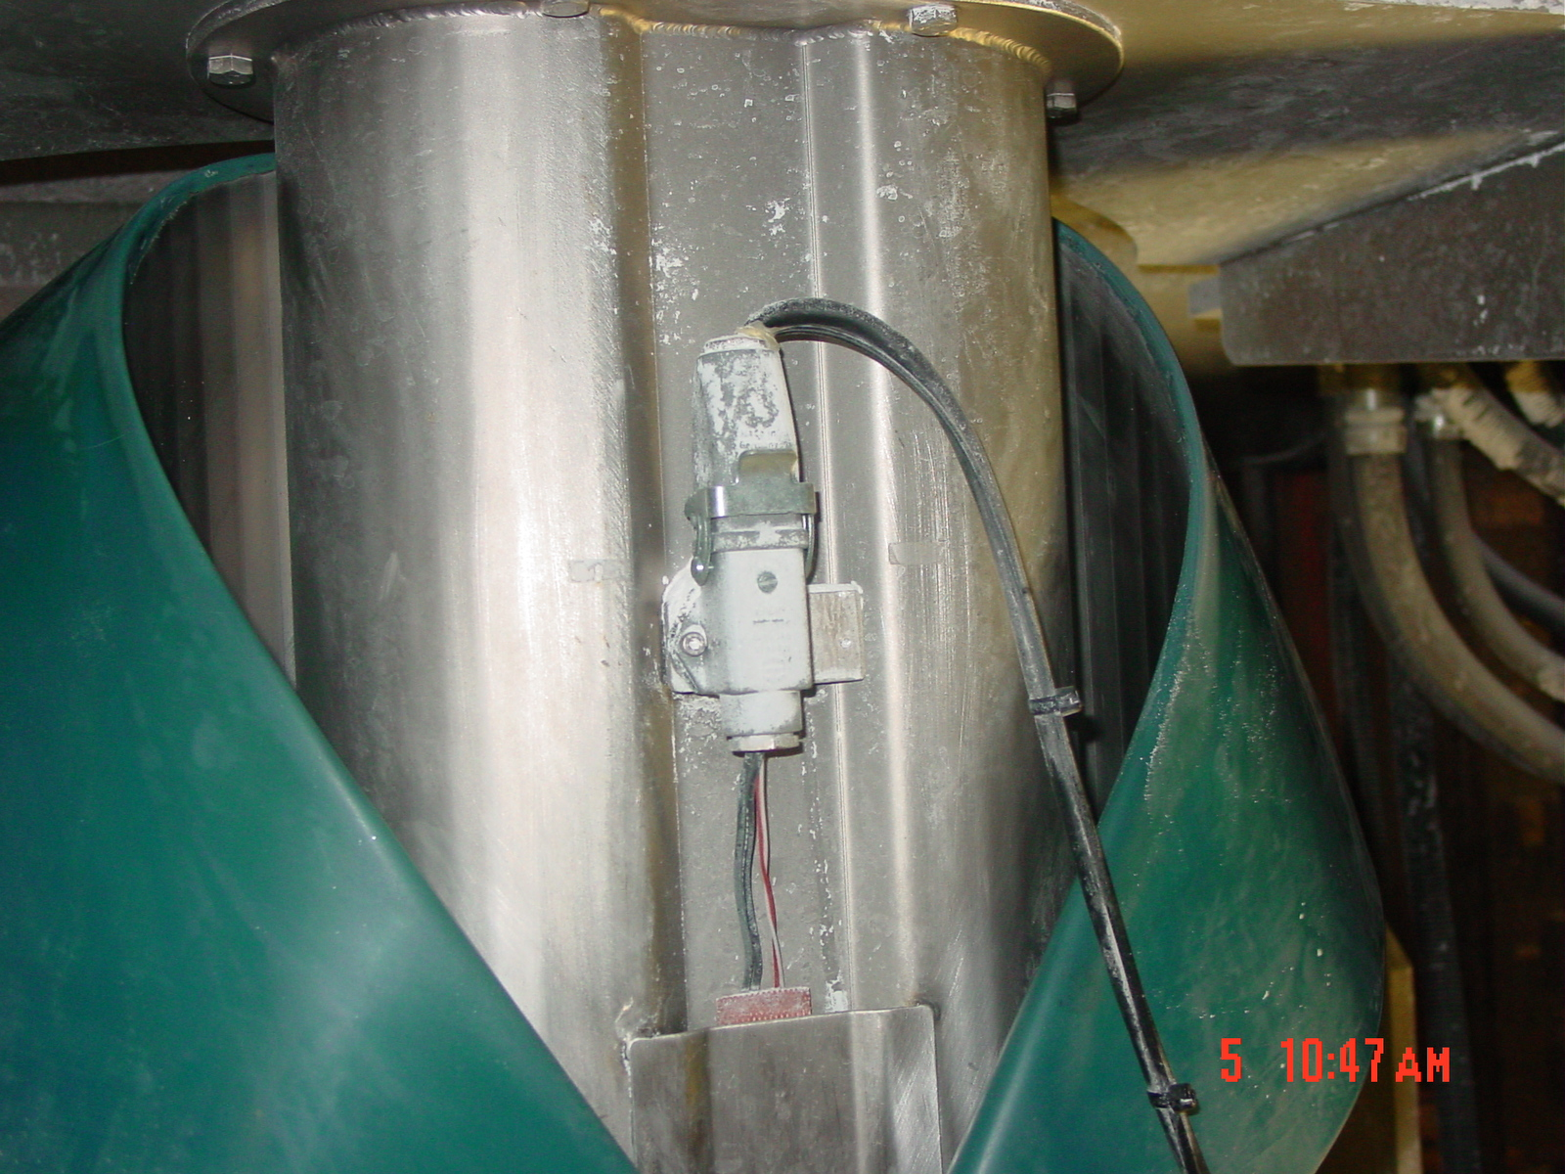
Thoroughly clean inside edge and outside of formatting head with ink conditioner

- Reference Documents

N/A

- Change Information

Document review- updated format using new template and numbering system.

